PRESS RELEASE
THE ULTIMATE GAME ROOM COMES ALIVE FOR A WEEKEND OF FUN AND FREE PLAY!
The Houston Area Arcade Group (HAAG) is holding their 10th Annual Arcade Expo on November 11th & 12th at the Houston Northwest Crowne Plaza at Pinemont and Hwy 290.
There will be over 200 classic and current coin-op pinball machines, video arcade games, penny arcades, and console video games ready for attendees to play on free play or buy them for their home. There will be Tournaments, events, music and workshops to keep the young and young at heart entertained.
- Pinball, Arcade & Console tournaments for trophies and cash prizes. Featuring the new Transformers Pinball, Tron, and Xbox 360 Kinect Wipe Out 2.
- The Houston Arcade Expo and Extra Life Benefiting the Children’s Miracle Network are working together to promote and raise money for this worthy cause -> Play Games, Heal Kids!!!!
- Activision will be Sponsoring our Tournaments with game prizes and give aways!
- Celebrate Pac-Man’s 31th anniversary by playing the real thing!
- Speakers will include Dan Ferguson (Lone Star Pinball Museum) on the History of Pinball, Ken Graham former Williams Programmer, Retro Pinball talking shop about their new pinball and many more.
- There will be Basic electronics, Pinball, and Arcade repair clinics to help attendee’s to get their machine’s back up and running or just to do basic maintenance.
- Classic Console games will be returning to the mix this year! Game systems. This includes Atari 2600, 5200, 7800, ColecoVision, Vectrex, Intellivision, Sega, NES, Xbox 360 and other modern & classic consoles.
- All Weekend at noon Star Wars http://imperial1.501stforums.com/ will be at the show come and meet your favorite member of the Empire & the Rebel Alliance!!!
- Free! Parking Lot Swap Meet, where you can buy and sell your project games and cool stuff
- Door prizes called out every 30 mins during the show,
- Try your luck at a game raffle to win a full stand up arcade.
- Pinball & Arcade games for Sale for your home or business. We will have tons of arcade and pinball parts, Manuals and memorabilia. Even great general memorabilia and comic books.
- Gene Cunningham of Illinois Pinball will have parts, Play Fields (8 Ball, Addams Family, Fun House ,DH , Kiss, NBA, etc..), and Back Glasses galore!!
- There will be concessions and a full bar available for you to purchase refreshments.
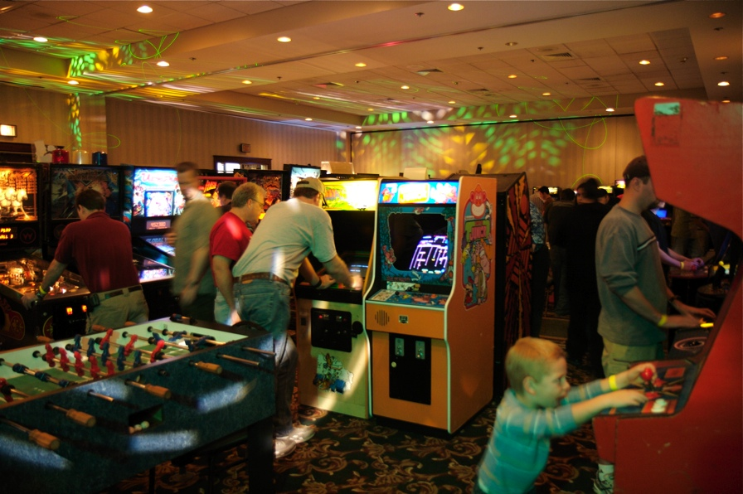
What: 2011 Houston Arcade Expo

Dates: November 11th & 12th , 2010

Hours:
Nov 11th: 6pm until 2am
Nov 12th: 10am until 2am

Location:
Houston Northwest Crowne Plaza
12801 NORTHWEST FREEWAY
HOUSTON, TX 77040 UNITED STATES

Tickets:
Admission is $30 for a weekend pass or $20 for a single day, which gets you access to over 150 arcade games and pinball machines all set to free play!

More info: 713-838-0038 ext 101 (Keith Christensen) or www.arcadecenter.com

