PRESS RELEASE
THE ULTIMATE GAME ROOM COMES ALIVE FOR A WEEKEND OF FUN AND FREE PLAY!
The Houston Area Arcade Group (HAAG) is holding their 8th Annual Arcade Expo on November 6th & 7th at the Crowne Plaza Reliant Center Hotel on Kirby right across the street from Reliant Center.
There will be over 150 classic and current coin-op pinball machines, video arcade games, penny arcades, and console video games ready for attendees to play on free play or buy them for their home. There will be Tournaments, events, music and workshops to keep the young and young at heart entertained.
- Retro Pinball, inc will be showing off their new pinball at the show this year, a remake of the 1967 King of Diamonds. They will be speaking and showing it off as they launch it for sale to the operator and home amusement markets.
- Speakers will include Dan Ferguson (Lone Star Pinball Museum) on the History of Pinball, Ken Graham former Williams Programmer, Retro Pinball talking shop about their new pinball and many more.
- There will be Basic electronics, Pinball, and Arcade repair clinics to help attendee’s to get thier machine’s back up and running or just to do basic maintenance.
- Classic Console games will be returning to the mix this year! Game systems. This includes Atari 2600, 5200, 7800, ColecoVision, Vectrex, Intellivision, and other classic consoles.
- Sat Nov 7th at noon Star Wars http://imperial1.501stforums.com/ will be at the show come and meet your favorite member of the Empire!!!
- You can also participate in arcade and pinball tournaments
- Free! Parking Lot Swap Meet, where you can buy and sell your project games and cool stuff
- Door prizes called out every 30 mins during the show,
- Try your luck at a game raffle to win a full stand up arcade or pinball.
- Pinball & Arcade games for Sale for your home or buisness. We will have tons of arcade and pinball parts, Manuals and memorabilia. Even great general memorabilia and comic books.
- Gene Cunningham of Illinois Pinball will have parts, Play Fields (8 Ball, Addams Family, Fun House ,DH , Kiss, NBA, etc..), and Back Glasses galore!!
- There will be concessions and a full bar available for you to purchase refreshments.
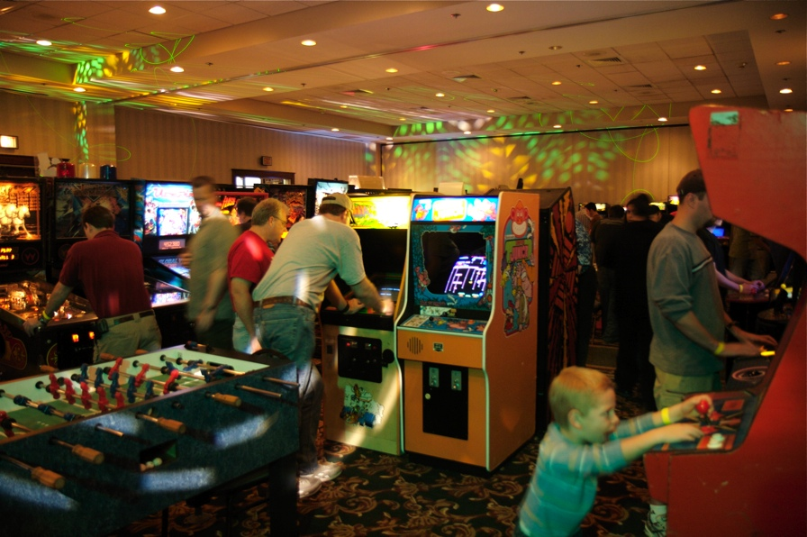
What:
2009 Houston Arcade Expo

Dates:
November 6th & 7th, 2009

Hours:
Nov 6th: 6pm until 2am
Nov 7th: 10am until 2am

Location:
Crowne Plaza Hotel
HOUSTON - MEDICAL CENTER
8686 KIRBY DRIVE
HOUSTON, TX 77054 UNITED STATES

Tickets:
Admission is $25 for a weekend pass or $15 for a single day, which gets you access to over 150 arcade games and pinball machines all set to free play!

More info:
713-838-0038 ext 101 (Keith Christensen) or www.arcadecenter.com

