PRESS RELEASE
THE ULTIMATE GAME ROOM COMES ALIVE FOR A WEEKEND OF FUN AND FREE PLAY!
The Houston Area Arcade Group (HAAG) is holding their 12th Annual Arcade Expo on November 8th & 9th at the Houston Northwest Crowne Plaza at Pinemont and Hwy 290.
There will be over 200 classic and current coin-op pinball machines, video arcade games, penny arcades, and console video games ready for attendees to play on free play or buy them for their home. There will be Tournaments, events, music and workshops to keep the young and young at heart entertained.
- Pinball, Arcade & Console tournaments for trophies and cash prizes. Featuring the new Metallica Pinball, Wizard of OZ Pinball, and Star Trek Pinball.
- Microsoft will be bringing 6 xbox 360’s for a tournament each day with a Xbox Party Prize (at the Microsoft Store) to the winner. We will also have an Xbox with Kinect setup on the big screen again this year. Microsoft will also be giving out to attendees a store discount card! Activision will be Sponsoring our Tournaments with game prizes and give aways!
- Guest Dirty" Donny Gillies is a freelance artist working mostly in the rock, punk and metal music industry designing album covers, show posters and band merchandise. He has produced work for such bands as The Hellacopters, The Melvins, Queens of the stone age, The Wildhearts, Electric Frankenstein and the 5.6.7.8's, but is most noted for his work with metal band Metallica.
- Guest Steven Scott Ritchie is an acclaimed pinball and video game designer. He has been called "The Master of Flow" by pinball aficionados due to the emphasis in his designs on ball speed, loops, and the like
- Speakers will include Dan Ferguson (Lone Star Pinball Museum) on the History of Pinball, Ken Graham former Williams Programmer, Retro Pinball talking shop about their new pinball and many more.
- There will be Basic electronics, Pinball, and Arcade repair clinics to help attendee’s to get their machine’s back up and running or just to do basic maintenance.
- Classic Console games will be returning to the mix this year! Game systems. This includes Atari 2600, 5200, 7800, ColecoVision, Vectrex, Intellivision, Sega, NES, Xbox 360 and other modern & classic consoles.
- All Weekend at noon Star Wars and other Costume Characters will be at the show come and meet your favorite member of the Empire & the Rebel Alliance!!!
- Free! Parking Lot Swap Meet, where you can buy and sell your project games and cool stuff, Door prizes called out every 30 mins during the show, Try your luck at a game raffle to win a full stand up arcade.
- Pinball & Arcade games for Sale for your home or business. We will have tons of arcade and pinball parts, Manuals and memorabilia. Even great general memorabilia and comic books.
- Gene Cunningham of Illinois Pinball will have parts, Play Fields (8 Ball, Addams Family, Fun House ,DH , Kiss, NBA, etc..), and Back Glasses galore!!
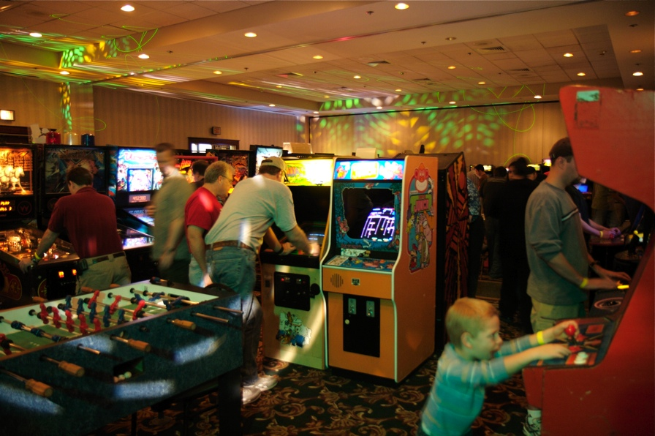
What: 2013 Houston Arcade Expo

Dates: November 8th & 9th , 2013

Hours:
Nov 8th: Noon until 2am
Nov 9th: 10am until 2am

Location:
Houston Northwest Crowne Plaza
12801 NORTHWEST FREEWAY
HOUSTON, TX 77040 UNITED STATES

Tickets:
Admission is $30 for a weekend pass or $20 for a single day, which gets you access to over 150 arcade games and pinball machines all set to free play!

More info: 713-838-0038 ext 101 (Keith Christensen) or www.arcadecenter.com

