PRESS RELEASE
THE ULTIMATE GAME ROOM COMES ALIVE FOR A WEEKEND OF FUN AND FREE PLAY!
The Houston Area Arcade Group (HAAG) is holding their 13th Annual Arcade Expo on November 7th & 8th at the Houston Northwest Crowne Plaza at Pinemont and Hwy 290.
There will be over 200 classic and current coin-op pinball machines, video arcade games, penny arcades, and console video games ready for attendees to play on free play or buy them for their home. There will be Tournaments, events, music and workshops to keep the young and young at heart entertained.
- Pinball, Arcade & Console tournaments for trophies and cash prizes. Featuring the new Walking Dead Pinball, The Big Lebowski™ Pinball.
- Pinball, Xbox fighter, Video Arcade, Xbox Console, and bubble Hockey tournaments all day Friday and Saturday!
- Guest Dirty" Donny Gillies is a freelance artist working mostly in the rock, punk and metal music industry designing album covers, show posters and band merchandise. He has produced work for such bands as The Hellacopters, The Melvins, Queens of the stone age, The Wildhearts, Electric Frankenstein and the 5.6.7.8's, but is most noted for his work with metal band Metallica.
- Guest Walter Day is considered the "Patron Saint of the Video Game Age". As the founder of Twin Galaxies in 1981, he worked towards establishing video game playing as a professional sport and inspired the creation of the International Video Game Hall of Fame in Ottumwa, Iowa.
- Guest Billy Mitchell In addition to being proclaimed the "Video Game Player of the Century" at the 1999 Tokyo Game Show, Billy has enjoyed eternal fame as the 1st person to achieve a "perfect" score on Pac-Man and for his mastery over Donkey Kong and Donkey Kong, Jr., among history's most revered games.
- Speakers will include Dan Ferguson (Lone Star Pinball Museum) on the History of Pinball, Ken Graham former Williams Programmer, Retro Pinball talking shop about their new pinball and many more. There will be Basic electronics, Pinball, and Arcade repair clinics to help attendee’s to get their machine’s back up and running or just to do basic maintenance.
- Classic Console games will be returning to the mix this year! Game systems. This includes Atari 2600, 5200, 7800, ColecoVision, Vectrex, Intellivision, Sega, NES, Xbox 360 and other modern & classic consoles.
- All Weekend at noon Star Wars and other Costume Characters will be at the show come and meet your favorite member of the Empire & the Rebel Alliance!!!
- Free! Parking Lot Swap Meet, where you can buy and sell your project games and cool stuff, Door prizes called out every 30 mins during the show, Try your luck at a game raffle to win a full stand up arcade.
- Pinball & Arcade games for Sale for your home or business. We will have tons of arcade and pinball parts, Manuals and memorabilia. Even great general memorabilia and comic books.
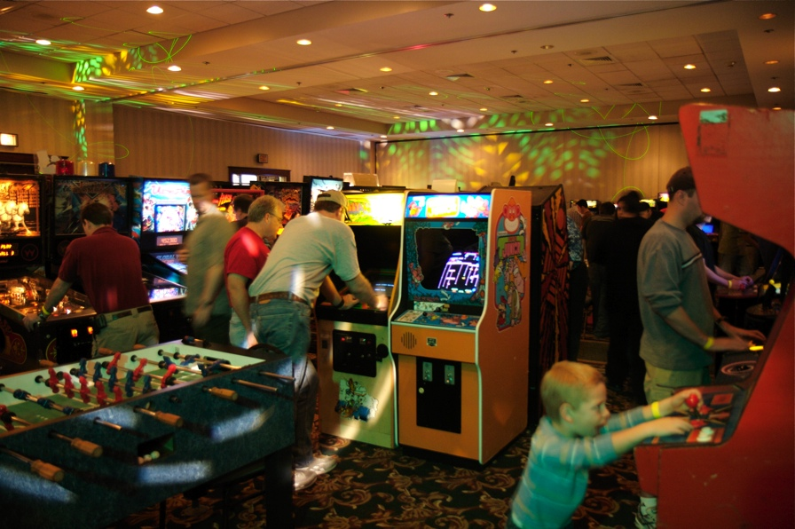
What: 2014 Houston Arcade Expo
Web Site: www.arcadecenter.com
Dates: November 7th & 8th , 2014

Hours:
Nov 8th: Noon until 2am
Nov 9th: 10am until 2am

Location:
Houston Northwest Crowne Plaza
12801 NORTHWEST FREEWAY
HOUSTON, TX 77040 UNITED STATES

Tickets:
Admission is $30 for a weekend pass or $20 for a single day, which gets you access to over 150 arcade games and pinball machines all set to free play!

More info: 713-838-0038 ext 101 (Keith Christensen) or www.arcadecenter.com

